The role of Ca²⁺, AMPA and NMDA receptors in the formation of glutamate-induced cofilin-actin rods in axons and dendrites during neuronal maturation

Qianhui Yang¹, Avery Runyan^{1,2}, Chi W. Pak^{1,3}, Laurie S. Minamide¹, James R. Bamburg¹

¹Department of Biochemistry and Molecular Biology, Colorado State University, Fort Collins, CO 80523-1870

Corresponding Author: James R. Bamburg
Department of Biochemistry and Molecular Biology
1870 Campus Delivery
Colorado State University
Fort Collins, CO 80523-1870
Tel: 970-491-6096;
Email: james.bamburg@colostate.edu
Other Email: qyang311@rams.colostate.edu;
laurie.minamide@colostate.edu
² Present address: Department of Neurobiology and Anatomy, Drexel University College of medicine, 2900 W. Queen Lane, Philadelphia, PA 19129 amr475@drexel.edu

³Present address: Department of Microbiology, University of Texas Southwestern Medical Center, 5323 Harry Hines Boulevard, Dallas, TX 75390-9048 chi.pak@utsouthwestern.edu

Abstract (247 words)

Bundles of filaments (rods) containing actin and cofilin form in neurites of stressed neurons where they cause synaptic dysfunction. In E18 rat hippocampal neurons cultured 5-7 days in vitro (DIV), excitotoxic levels of glutamate induce rod formation that occurs predominantly in dendrites and is mediated by AMPA receptors independent of extracellular Ca²⁺. Here we examine if the glutamate receptors responsible for rod formation change during development and address the location of rods between axons and dendrites in rat hippocampal neurons cultured for 7, 14 or 21 DIV and treated for 1 hr with glutamate. Inhibition of metabotropic glutamate receptors had no effect on rod formation at any age in culture. Antagonists of AMPA receptors blocked rod formation at all ages of development whereas antagonists of NMDA receptors did not decrease glutamate induced rod formation at 7 DIV but did decrease rods in neurons 14 and 21 DIV. The number of rods/neuron induced by AMPA declines between 7 and 14 DIV although total glutamate-induced rods/neuron doubled, confirming the increased role for NMDA receptors in rod formation during maturation. Furthermore, glutamate-induced rod formation in neurons 7 DIV was Ca²⁺-independent whereas by 21 DIV rod formation showed increasing dependence on extracellular Ca²⁺? Rod formation is highest in dendrites of neurons 7 DIV but by 14 DIV rods form predominantly in axons. Blockage of vesicular transport and distal neurite function by rods suggest their axonal location would greatly impact the participation of the neuron in which they form within its electrical circuit.

Also input effects of CsA and other PP2B inhibitors if appropriate. No effect at day 7.
On 7 DIV, the inhibitor of calcineurin didn’t eliminate the glutamate induced rod formation even though the intracellular Ca²⁺ concentration rise rapidly after AMPA treatment.

Introduction
1. Cofilin as regulator of actin dynamics and synapse function
Neurons, among the most highly specialized and morphologically distinct cell types, typically consist of a cell body (soma), an axon and multiple dendrites. The dendrites serve to receive chemical or electrical signals and the axon serves to pass the integrated input onto its targeted cell, often another neuron, a muscle cell, or a secretory cell. The neuronal cytoskeleton, consisting of microtubules, actin filaments, intermediate filaments, and their interacting proteins, is essential for the development and maintenance of neuronal architecture and function(Yuan et al. 2012; Conde and Cáceres 2009; Hotulainen and Hoogenraad 2010; Konietzny, Bär, and Mikhaylova 2017; Dent and Gertler 2003).
Actin filament assembly and disassembly is highly regulated and controls many aspects of neuronal development, including shrinkage and enlargement of the major postsynaptic compartment on excitatory neurons, the dendritic spine (Hotulainen and Hoogenraad 2010). Although spine size may be regulated independently from insertion or removal of neurotransmitter receptors (Kopec 2006), spine shrinkage usually accompanies low frequency stimulation, which results is loss of receptors and development of long-term depression(Zhou, Homma, and Poo 2004). High-frequency stimulation leads to increased receptor insertion into the postsynaptic membrane, which is also accompanied by spine enlargement and the formation of new dendritic spines, this is related to the AMPA receptors insertion and depends on NMDA receptors activation triggered by high-frequency stimulation, all of these changes increase the synapses strength which is called long term potentiation, an electrophysiological correlate of learning and memory (Kopec 2006) (Huber and Menzel 2004)(Giese 2011).

Among the plethora of proteins that regulate actin dynamics, members of the actin
depolymerizing factor (ADF)/cofilin family seem to be essential. Cofilin can dramatically enhance actin filament turnover by binding to, twist and severing filamentous actin (F-actin), a process depends on the concentration of ATP-actin pool that is enhanced or depressed by many other proteins(McGough et al. 1997; Carlier et al. 1997; review from Shaw and Bamburg 2017). ADF/cofilin proteins undergo phosphoregulation, both of them are inactivated by phosphorylation on Serine 3 by LIM kinase and are activated by phosphatase either slingshot or chronophin. 1. A Ras/Rap GTPase-activating protein, SynGAP, was shown to be essential in regulation of actin in mature spines in mice by signaling downstream through phosphoregulation of cofilin-1(Carlisle et al. 2008), the ADF/cofilin isoform most prevalent in rodent neurons(I can not find publication work to support this). 2. Indeed, direct and indirect modulation of cofilin kinase and phosphatase activity by genetics (LIMK knock-out, Slingshot small iRNA and cofilin overexpression), expression of cofilin with mutations in the phosphorylation site, or cell-permeable peptide inhibitors (Y. Wang et al. 2013; Noguchi et al. 2016), demonstrated phosphoregulation of cofilin is essential for AMPA receptor trafficking, LTP and dendritic spine growth and function which relate to memory under normal conditions (Meng et al. 2004; Gu et al. 2010; Yuen et al. 2010; Y. Wang et al. 2013; Noguchi et al. 2016) Many spine abnormalities thought to be causative in a significant number of psychiatric, cognitive and neurological disorders stem such as fragile X syndrome and Alzheimer’s disease from aberrant cofilin phosphoregulation(Jacobsen et al. 2006; Lanz, Carter, and Merchant 2003; Noguchi et al. 2016). Indeed, cell permeable peptide modulators of the cofilin phosphorylation state have been used effectively in correcting, at least transiently, behavioral and cognitive deficits in mouse models of disorders including Alzheimer disease, aggressive behavior, autism, neuropathic pain, and cognitive dysfunction associated with sleep deprivation (Review from Shaw and Bamburg 2017)

2 Cofilin-actin rods in neuronal stress (in dendrites and axons of cultured 5-7 DIV neurons)
Cofilin-actin Rods
When present at sufficient amounts, cofilin binds to F-actin in a cooperative manner and the pieces of F-actin saturated with cofilin (1:1 cofilin: actin) are quite stable. Under conditions of cell stress, almost always accompanied by increased production of reactive oxygen, cofilin: actin complexes assembly into large rod-shaped aggregates (rods) (Minamide et al. 2000) that linked by disulfide bond. Rods have been isolated from neurons (Minamide et al. 2010) and contain intermolecular disulfide bond-linked cofilin dimers (Bernstein et al. 2012). In neurons, rods were observed within dendrites and axons by various types of stimulations through two possible pathways( Bamburg and Bernstein 2016; Cichon et al. 2012; Minamide et al. 2000). Stimulations including excitotoxic level of glutamate, mitochondrial inhibitors, peroxides, A$β peptides$, or proinflammatory cytokines(Longitudinal, Structural, and Models 2015). Among these rod-inducing agents, A$β peptides$ and proinflammatory cytokines depend on a pathway that requires the cellular prion protein and NADPH oxidase (NOX) to generate reactive oxygen species (ROS) to induce the rods. Rod induction by mitochondrial inhibitors and excitotoxic levels of glutamate are through pathways independent of the cellular prion protein and NOX(Walsh et al. 2014).
In the mammalian central nervous system, glutamate is the major excitatory neurotransmitter important for learning and memory but can also become neurotoxic if it is in excess. Glutamate excitotoxicity has been demonstrated in many different neurodegenerative diseases and cerebral ischemia ( review from Lau and Tymianski 2010; review from R. Wang and Reddy 2018; review from Nishizawa 2001).Among different glutamate receptors, the activation of NMDA receptors appears to be primarily responsible for excitotoxicity by excess glutamate by leading to the excessive Ca²⁺ entry into the cell(Tymianski et al. 1993; Koh and Choi 1991).
Related to our studies, glutamate has been found to induce cofilin-actin rods in over 80% of hippocampal neurons 7 DIV working via AMPAR but not NMDAR and are not Ca²⁺ dependent(Bernstein et al. 2012). While (Chen et al.) around the same time has discovered that glutamate could induce rods in rods in 2 phases; one formed about 1 h after the treatment, and the second phase start at 8h after treatment. Besides, they also discovered that in both phase, glutamate induced rods in hippocampal neurons 10DIV depend on both AMPA and NMDA receptors to form. Need to add

literature update with papers from Rust, Yuen, Carlisle, Chen, Wang, Cao, Gu, Noguchi
Here we show: Consistent to our

To here
Methods and Materials

Ethics statement: Time pregnant rats were handled according to the National Research Council's Guidelines to Care and Use of Laboratory Animals as approved by the Colorado State University Animal Care and Use Committee (approved protocol #17-7541A).

Cell Culture: Hippocampal neurons were obtained from embryotic day 18 (E18) rat (Sprague Dawley, Envigo)., The hippocampi were incubated in 2.5% Trypsin (10X) (Sigma, T4549) in HBSS (50 ml 10X HBSS (Sigma H4641),16.5ml 0.3M pH7.3 Hepes, 440ml ultrapure water filter sterilize) and then triturated with a cotton plugged Pasteur pipet. The cells were stored in neurobasal/FBS containing 10% DMSO in aliquots at a density of 10⁶ cell/ml, frozen by overnight incubation at -80 $℃$and stored in liquid nitrogen until use.
Sterile coverslips (15 mm) were coated with sterile 0.1% poly-D-lysine (Sigma, P0899) in borate buffer overnight (50mM H₃BO₃, 12.5 mM Na₂B₄O₇) and then placed in wells of a 24-well plate. Hippocampal neurons were thawed at 37 $℃$, diluted in L-Glutamine-free Neurobasal Medium (Invitrogen, 21103-049) containing10% Hyclone fetal bovine serum (VWR, 6777-002) and plated on the poly-D-lysine coated coverslips at a density of 15,000 neurons per well. After 2 h incubation, the medium was removed and replaced with serum-free Neurobasal Medium containing 1X N21 Max (Fisher, AR008), 50 Unit/mL Penicillin and 0.08 mM Streptomycin (Fisher Scientific Hyclone, SV30010), and 5$μM$glutamine (Intvitrogen, 35050-061).
For DIV7 cultures, the cells were maintained in the culturing medium in a 37$℃$, 5% CO₂, humidified incubator. Half of the medium was changed every 4th day. For the longer term DIV14, DIV21 cultures, the cells were treated with 0.5 mM 5-Fluoro-2’-deoxyuridine on DIV4 and then half of the medium was changed on DIV5 and every 4th day thereafter.

Treatment with glutamate receptor antagonists and agonists:

The following glutamate receptor agonists and antagonists were prepared and used at the final concentrations given: Antagonists (all added 15 min prior to L-Glutamate or AMPA): DNQX (Tocris): prepared in water at 20 mM and used at 50 µM. MCPG (Alexis Biochemicals): prepared in 0.1 mM NaOH at 20 mM and used at 500 µM. AP5 (Sigma): prepared in Neurobasal Medium at 5 mM and used at 100 µM. Agonists: L-Glutamate: Prepared in Neurobasal Medium at 20 mM and used at 100 µM.(S)-AMPA (Tocris): Prepared in Neurobasal Medium at 10 mM and used at 100 µM. (RS)-DHPG (Tocris): Prepared in Neurobasal Medium at 5 mM and used at 100 µM. Before drug addition, the volume of medium in each well was measured and adjusted to be identical across wells before drug treatment.

Immunostaining:
Cultured neurons were fixed for 20 min at room temperature with 4% paraformaldehyde (Tousimis, 1008A) in 1X PBS (137 mM NaCl, 2.7 mM KCl, 10 mM Na₂HPO₄, pH to 6.4) pre-warmed to 37º C. After several washes with PBS and its removal, the cells were permeabilized with -20$℃$MeOH (Fisher Chemical, A408-4) for 90 seconds. Following several washes with PBS, cells were treated for 45 mins with 2% goat serum (Sigma Aldrich, L5163) and 1% bovine serum albumin (Sigma Aldrich, A9647) in Tris-buffered saline (50 mM Tris, 150 mM NaCl, pH to 7.6). After three TBS washes, neuronal cells were stained with primary antibody at 4$℃$overnight. After another three TBS washes, secondary antibodies were applied for 60 min. After another three TBS washes, coverslips were mounted on glass slides with 5 µL Prolong Diamond Antifade Mount (Molecular Probes, P36961) and after air drying overnight in the dark, slides were stored in the dark at 4$℃$.
The primary antibodies used include: purified rabbit IgG antibody to chick ADF (1439) (1 ng/mL) which reacts with mammalian ADF and cofilin to detect rod formation; Chicken polyclonal IgY Map2 (1:500) to identify dendrites; mouse anti neurofilament IgG (1:300- 3.3µL/mL) to identify axons. Secondary antibodies include goat anti-rabbit IgG Alexa Fluor 640 (1:500); goat anti-mouse IgG Alexa Fluor 568(1:500); goat anti-chicken IgG Alexa Flour 488 (1:500).

Quantification of Cofilin-Rod Formation:

Fixed and stained neurons were examined with a 40X oil objective on an Olympus IX 83 microscope with Yokagawa CSU22 spinning disk confocal system and images were taken by on a CoolSnap HQ camera controlled by Slidebook software. Slides were randomly coded by others, scored blind, and were revealed after the quantification.
Rods, stained by the ADF/cofilin antibody, appear as elongated rod-shape structures with high fluorescence intensity. Two different methods were used to score rod formation: percent rod index and number rod index. Percent rod index is the percent of total neurons examined that formed at least one rod. The number rod index is the average number of rods counted per field divided by the total number of neuronal soma per field (i.e. rods/soma). For each quantification, 100 fields were quantified from each coverslip with each field having at least one soma.
Dendrites and axons were distinguished by both immunostaining and morphology. For DIV7 and DIV14 cultures, the immunostaining itself is enough to identify the process whereas for DIV21, neurofilament staining is not very distinct so morphology is more often used to identify the axon for rod quantification. Axons are thin, smooth and long with constant diameter whereas dendrites are shorter and wider, tapering from the soma. They often have a rough surface due to dendritic spines.

Statistics

All of the rod quantifications were done in triplicate and were repeated twice (minimum of 600 neurons quantified). All the calculations and statistical tests (student “t” test, ANOVA) were done using JMP software (SAS Institute) and were graphed using Excel.

Results

Metabotropic glutamate receptors do not mediate the rod response to glutamate during neuronal maturation

Previous studies showed that 100-150 µM L-glutamate induced in 5-7 DIV cultured E18 rat hippocampal neurons a rapid (20-30 min) and robust in (>80% of neurons) formation of cofilin-actin rods (Bernstein et al., 2012). Glutamate-induced rods were not inhibited by the metabotropic glutamate inhibitor MCPG. Here we repeated and extended that finding. Figure 1 shows neurons that were cultured for 7, 14 or 21 DIV and untreated (control), or treated with L-glutamate (100 µM (7DIV) or 150 µM (14 or 21 DIV)), (R,S) MCPG (500 µM), or 15 min with MCPG prior to and during L-glutamate treatment. (NOTE: You might not want to include any of the staining for axons and dendrites at this stage- and wait to present this with the section on rod location later on). After fixation and immunostaining for cofilin, rods were quantified both in terms of rods/neuron (Rod Number Index) and percent of neurons with rods (Percent Rod Index). As observed previously, the pretreatment of neurons 7DIV with MCPG did not diminish the rod response (Figure 2). A robust rod response to L-glutamate was also observed for neurons 14 and 21 DIV and the response was not significantly reduced by a 15 min pretreatment with MCPG, used at almost twice the concentration shown to fully inhibit the activation of extracellular receptor kinase (ERK) by both mGluR1a and mGluR2 receptors (Ferraguti, F et al (Corti C, lab) Eur J Neurosci 11, 2073-2082, 1999). These results suggest that the metabotropic glutamate receptors play no significant role in the neuronal cofilin-actin rod response during the first 3 weeks of neuronal maturation, the longest period followed.

Formation of cofilin-actin rods in hippocampal neurons 7 DIV is mediated by AMPAR and not NMDAR.
Previous studies have demonstrated that ionotropic AMPA receptors are responsible for the rod induction by glutamate in hippocampal neurons culture 5-7 DIV. We reproduced these findings in our 7 DIV cultures by showing robust rod responses to 100 µM L-glutamate (Figure 3) that were not attenuated quantitatively in either the Rod Number or the Percent Rod responses by 15 min pretreatment with the NMDAR antagonist AP5 (100 µM), but which were fully inhibited by the AMPAR antagonist DNQX (50 µM) (Figure 4).

A gradual shift between AMPA and NMDA receptors for glutamate-induced cofilin actin rod formation occurs during in vitro maturation of hippocampal neurons.
NOTE: now include here the NEW data showing the neuronal pictures and rod quantification for 14 DIV and 21 DIV with a shift from fully AMPAR dependent to partially dependent on NMDAR (increased AP5 inhibition of rod response and slightly less than full inhibition with DNQX (although AMPA channels may also be needed to allow NMDAR function- this is why there won't be a big decline in DNQX effectiveness, just a switch to the greater need for NMDAR). But, this should show up in AMPA-induced rods- I see one set of data in 14 DIV neurons showing AMPA being less effective than glutamate in rod induction, which you would expect if the glutamate response is becoming more NMDAR-dependent. It would be great if you have 21 DIV data that shows an even more reduced AMPA rod-inducing effect since AMPA should open only AMPA channels and not NMDA channels. This then leads into the AMPA data specifically.

You can then finally focus on the location of rods- being mostly dendritic early on and shifting to axonal in more mature neurons.
You can work in the FdU experiments where you think they best fit.

We sought to characterize the effect of (L)-glutamate and (S)-AMPA on the neurons in terms of their ability to form cofilin-actin rods on the neurites. Immunostaining on primary rat E18 hippocampus cells plated on poly-D-lysine coated coverslip and spinning disk confocal microcopy shows rods formed dramatically increased after treated with 1h 100µL (L)-glutamate and 30 min 25µL (S)- AMPA on DIV7, and 1h 150µL (L)-glutamate and 1h 50µL (S)- AMPA on DIV14 and 21. Treatments concentration and time are decided to follow previous studies from the lab to make sure enough rods are induced to provide significant data for the later antagonist treatment ^{37,71}. Immunostaining and the following quantification show that glutamate and AMPA pretreatment can induce rods formation in cell and the number of the rods per cell that are recognize by cofilin stain and morphology on different stages (Figure 1B,2B,3B). In addition, different from previous observation, there is an 50% increase rods formation from DIV7 to DIV14 and 50% decline from DIV14 to DIV21 which is different from previous observation I am not clear on whose previous observation you are comparing this to. You are the only one to look at 14 and 21 DIV rods. (Figure 1B,2B,3B), the possible cause could be the 5-Fluoro-2’-deoxyuridine treatment in our experiment increase the exposure area of the neurites that are not been quantified in the previous experiment and also the inhibition of glia cells around the gap junction could increase chance of glutamate been exposed to the post-synapse region⁷¹.

Antagonist of AMPA receptors reduce the rods in young cultures (DIV7).

Next, we want to see the if the antagonist to AMPA receptors and NMDA receptors will inhibit the formation of rod in neurites on young culture. Consistent with the previous experiment³⁷, the AMPA receptor antagonist DNQX (6,7-dinitroquinoxaline-2,3-dione) drag the rods index and percent down to the control level (Figure 1). Together, we conclude that AMPA receptor is responsible for the excess level of glutamate induced rods formation in young culture (DIV7).

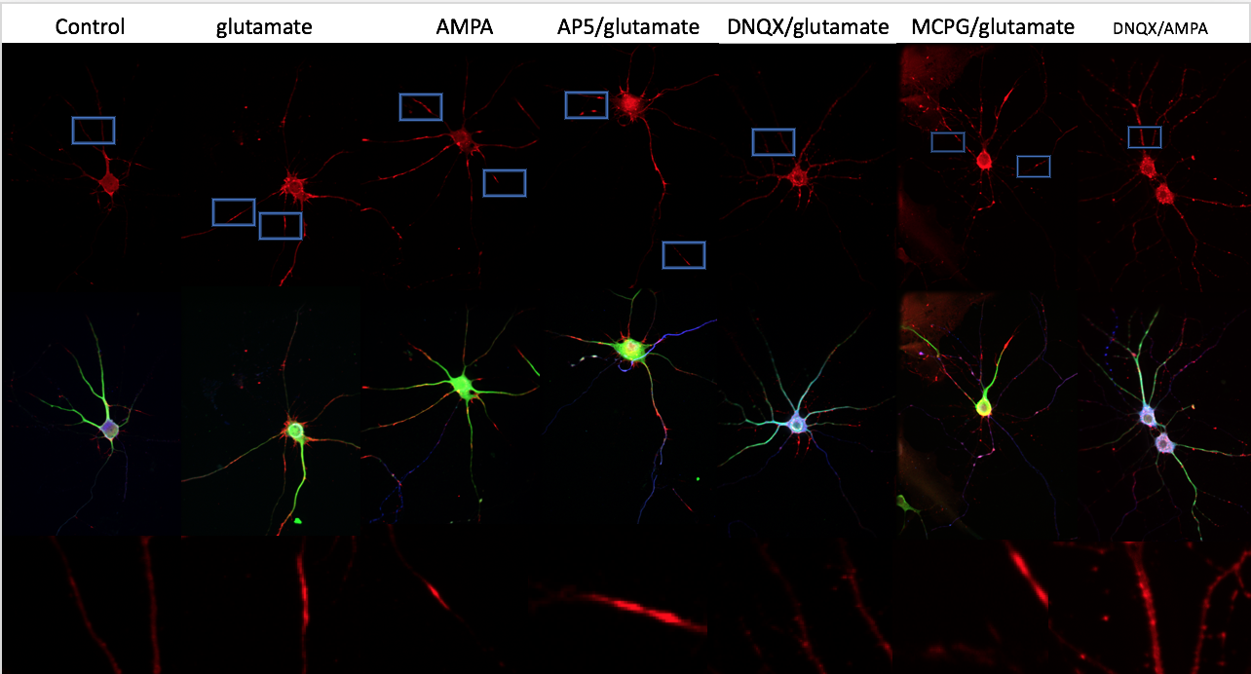
Figure 1A

Figure 1B

Figure 1A. Inverted Fluorescence image of E18 hippocampus neuronal cells culture DIV7. Cells were fixed and stained with MAP2, neuronfilament and ADF/cofilin. Image of neuron with cofilin alone are shown in the first lane, the merged images are shown in the second lane. The rods structures or the area with high cofilin expression are highlighted by blue box and are zoomed in shown in the third lane. (L)-glutamate is treated 100 µL for 1h and (S)-AMPA is treated 25µL for 30min and antagonists are treatment 15 min prior to the agonists treatment, DNQX 50 µL, APV 100 µL, MCPG 500 µL.
Figure 1B. The following quantification of rods index and rods percent. All of the quantifications were done in triplicate and were repeated twice (minimum of 600 neurons quantified). All the calculations and statistical tests (student “t” test, ANOVA) were done using JMP software (SAS Institute) and were graphed using Excel. *P ≤ 0.05 and **P ≤ 0.01.

Antagonist of NMDAR will have a greater effect on rod formation in culture with mature synapses than young culture.

Our next question is that during the development of neuronal cell, if the switch of the subunit on NMDA receptor could lead to the neuronal cells to be more sensitive to the excess level of glutamate. APV as the antagonist to the NMDA receptors are applied prior to the glutamate and AMPA treatment. APV doesn’t decrease the rods formation on DIV 7 culture but does decrease the rods index from 9.587 rods/neuron to 1.02 rods/neuron and rod percent from 87.6 percent to 52.3 percent on DIV14 and is more effective on DIV21 culture that decrease the rods index from 4.98 rods/neuron to 0.69 rods/neuron and rod percent from 92.56 to 35.212 rods/neuron. Therefore, we conclude that during the neuron mature, NMDA receptors start to responsible for the excess level of glutamate and lead to the formation of rods in neurites.

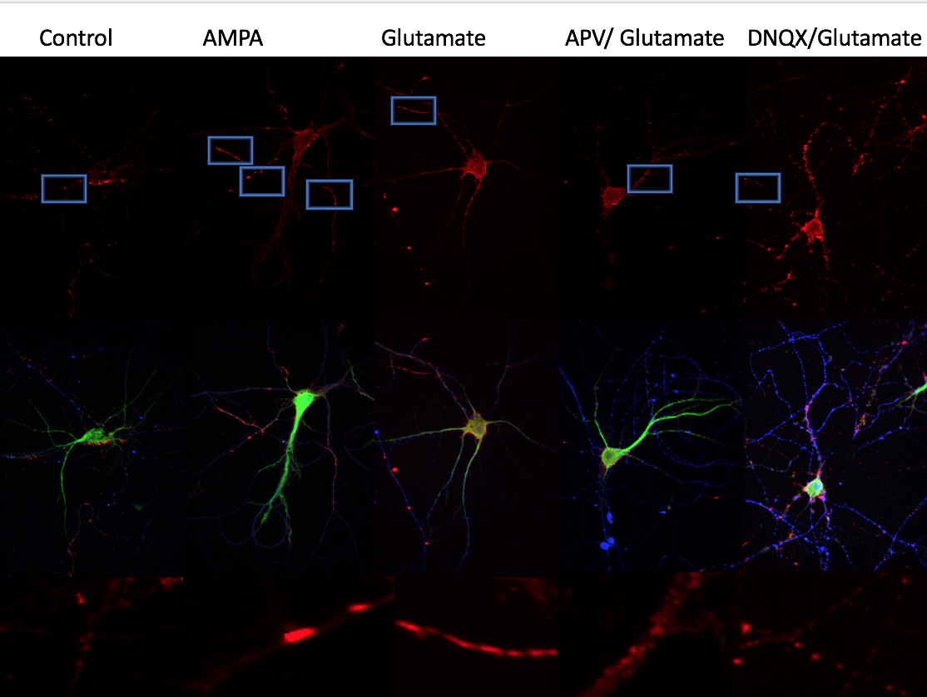
Figure 2A

Figure2B

Figure 2A. Inverted Fluorescence image of E18 hippocampus neuronal cells culture DIV14. Cells were fixed and stained with MAP2, neuronfilament and ADF/cofilin. Image of neuron with cofilin alone are shown in the first lane, the merged images are shown in the second lane. The rods structures and the area with high cofilin expression are highlighted by blue box and are zoomed in shown in the third lane. (L)-glutamate is treated 150 µL for 1h and (S)-AMPA is treated 50µL for 1h and antagonists are treatment 15 min prior to the agonists treatment, DNQX 50 µL, APV 100 µL, MCPG 500 µL.
Figure 1B. The following quantification of rods index and rods percent. All of the quantifications were done in triplicate and were repeated twice (minimum of 600 neurons quantified). All the calculations and statistical tests (student “t” test, ANOVA) were done using JMP software (SAS Institute) and were graphed using Excel. *P ≤ 0.05 and **P ≤ 0.01.

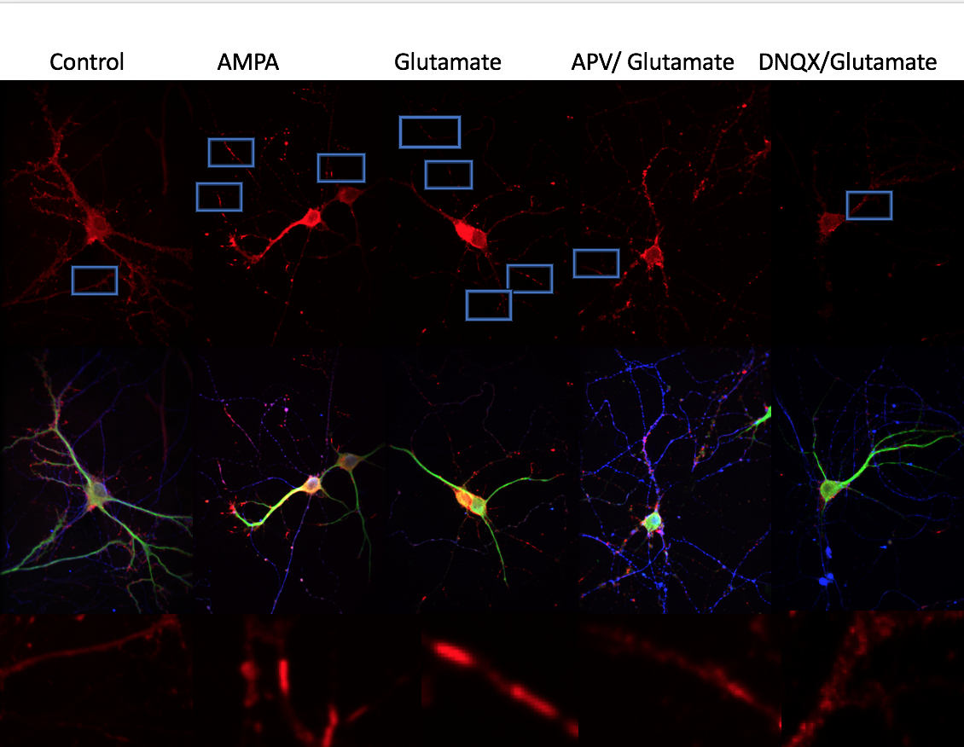
Figure 3A

Figure 3B

Figure 3A. Inverted Fluorescence image of E18 hippocampus neuronal cells culture DIV21. Cells were fixed and stained with MAP2, neuronfilament and ADF/cofilin. Image of neuron with cofilin alone are shown in the first lane, the merged images are shown in the second lane. The rods structures or the area with high cofilin expression are highlighted by blue box and are zoomed in shown in the third lane. (L)-glutamate is treated 150 µL for 1h and (S)-AMPA is treated 50µL for 1h and antagonists are treatment 15 min prior to the agonists treatment, DNQX 50 µL, APV 100 µL, MCPG 500 µL.
Figure 3B. The following quantification of rods index and rods percent. All of the quantifications were done in triplicate and were repeated twice (minimum of 600 neurons quantified). All the calculations and statistical tests (student “t” test, ANOVA) were done using JMP software (SAS Institute) and were graphed using Excel. *P ≤ 0.05 and **P ≤ 0.01.

Glutamate induced rod formation will be highest in dendrites of young (DIV7) neurons but will be much higher in axons of mature neurons (DIV14, DIV21).

Lastly, we want to localize the rods in the neuronal cell to see if they stay at the same location during the neuronal maturation. Neuronal cells are treated with 150 µL glutamate for 1 h in DIV7,14,21 culture and 50 µL AMPA for 1h in DIV14,21 culture and 25 µL AMPA for 30min for DIV 7 culture. The high AMPA concentration doesn’t induce as much as rods index in DIV7, so we decide to use date from the low concentration treatment. The localization of the rods is decided by the immunostainings of MAP2 and neurofilament which are highly expressed in dendrites and axons and also the morphology. We observed a change of location of rods from dendrites to axons during the neuronal maturation, glutamate induced rod formation will be the highest in dendrites of DIV7 neurons but will be much higher in axons of mature neurons (DIV14, DIV21).

Figure 4

Figure 4. The quantification of axonal and dendritic rods on DIV7,14 and 21. The orange region represent the dendritic rods number and the blue region represent the axonal rods number. The localization of rods is decided by immunostaining of MAP2 and neurofilament and morphology.

5-Fluoro-2’-deoxyuridine treatment on DIV14 culture possibly sensitize the NMDA receptor to the excess level of glutamate. Figure of glutamate and APV treated DIV14 neuronal culture with or without APV pretreated and with or without FDU treatment.

APV inhibition to NMDA receptors are more effective when the neuronal cells are treated with 5-Fluoro-2’-deoxyuridine. This probably indicates that NMDA receptors are more sensitive to the excess level of glutamate when there are less glia cells around them, or simply show the glia cell wrapping the gap junctions structurally block the antagonist from reaching the NMDA receptors.

Figure 5

Figure 4. The quantification of rods index and percent without 5-Fluoro-2’-deoxyuridine treatment. The APV did drag the rods index from 6.9833 to 5.64 with P= 0.1998, While APV didn’t show its ability to decrease the rod percent.

Figure 4.3. Ca²⁺ or the Ca²⁺-dependent proteins, calcineurin or calpain, are not essential for AMPA-induced rod formation. (A.) Rat hippocampal neurons were loaded with Fura2-AM, which is de-esterified to Fura2 by cellular esterases, for Ca²⁺ imaging. The peak excitation wavelength of Fura2 shifts to 380 nm from 340 nm upon Ca²⁺ binding; thus, a larger (380/340) ratio indicates higher Ca²⁺ concentrations. Each panel shown indicates a (380/340) ratio image. Before AMPA treatment, 380- and 340-nm images were captured for each neuron to establish a baseline (380/340) ratio, which was then normalized to 100%. (S)-AMPA treatment induces a rapid and robust Ca²⁺ response in hippocampal neurons (see top panels [post-AMPA ratio: 155; pre-AMPA ratio: 95]), which can be blocked by EGTA pre-treatment (see bottom panels [post-AMPA ratio:113; pre-AMPA ratio: 86] ). (B.) Quantification of Fura2 (380/340) ratio over over a total of 45 min at various timepoints: 2.5, 5, 7.5, 10, 15, 40 min. 25 µM (S)-AMPA (red squares) treatment induces a rapid increase in cytoplasmic Ca²⁺, which is sustained over 45 min (Ca²⁺ overload). The Fura2 ratio actually decreases in untreated neurons over this same timeframe (blue squares). 6 mM EGTA pre-treatment (green squares) blocks all Ca2+ responses induced by (S)-AMPA treatment. The Fura2 ratio for EGTA-treated neurons is lower than that observed for untreated neurons. (C.) 5-7 div rat hippocampal neurons were pre-treated with EGTA (6 mM) or various drug-inhibitors before treating with 25 µM (S)-AMPA to test whether rod formation could be blocked. The following drug inhibitors were used at the following concentrations: (Cyclosporin A, 20 µM), (FK-506, 25 µM), (ALLN, 50 µM), (E-64d, 15 µM). Neither EGTA pre-treatment nor any of the drug-inhibitors tested prevented rod formation. Some of these results will need to be repeated to determine their significance.

Discussions

When phosphorylated on ser3, its actin-binding phosphoregulatory site, phospho-cofilin no longer binds to actin but it will bind to and activate phospholipase D1 (Han L, EMBO J 2007) and thus increase levels of membrane phosphatidic acid, which depresses expression of the tumor suppressor protein p53 (Hui L, et al Mol Cell Biol 2004), and also mediates activation of DOCK2, which contains a PA binding domain (Nishikimi A, et al., Science 2009). For example, Cofilin, which has 4 Cys residues, can also form a single or double intramolecular disulfide bonds. Dephosphorylation of cofilin by slingshot (Woo JA et al., Cell Death Differ 2015) or chronophin (Kim JE et al., 2010) along with the oxidation of cysteines to form intramolecular disulfide bonds decreases cofilin's actin-binding and enhances its localization with mitochondria where it functions, perhaps in association with p53(Liu T et al, Sci rep 2017) or Drp1 (Li, G. et al., Oncotarget 2015) or through dissociation of cofilin from a complex with Bax (Simonishvili et al 2013 ASN Neuro), to trigger apoptosis (refs: Chua BT et al Nat Cell Biol 2003, Klampt F et al., 2009 Nat Cell Biol; Woo JA et al Cell Death Differen 2012; ) but see Rehklau Ket al and R MBust MB, Cell Death Differ 2012).

Future Directions

References:

- Adeboye, A. (Eds.). (2016). Drug discovery approaches for the treatment of neurodegenerative disorders. United Kingdom and United States: Elsevier.
- Harvard NeuroDiscovery Center. The challenge of neurodegenerative disease. Retrieved from https://neurodiscovery.harvard.edu/challenge
- Alzheimer’s Association. (2014). Alzheimer’s Disease facts and figures. Alzheimer’s and Dementia, Volume 10, Issue 2.
- Kowal, S.L., Dall, T. M., Chakrabarti, R., Storm, M.V., Jain, A. (2013). The current and projected economic burden of Parkinson’s disease in the United States. Movement Disorders, 28 (3), pp. 311–318. https://doi.org/10.1002/mds.25292
- Murphy, S.L., Xu, J., Kochanek, K.D. (2013). Death: final data for 2010. National Vital Statistics Reports 61 (4), pp. 1–117.
- Seegert, L. (2014). Incidence of Alzheimer’s Disease continues to rise as boomers age. Association of Health Care Journalists. Retrieved from https://healthjournalism.org/blog/2014/05/incidence-of-alzheimers-disease-continues-to-rise-as-boomers-age/
- Batista, P.; Pereira, A. (2016). Impact and Prevention of Neurodegenerative Diseases in society: Alzheimer and Parkinson. Neurodegenerative Diseases,1-11. Retrieved from http://www.smgebooks.com/Neurodegenerative-Diseases/chapters/ND-16-01.pdf
- Carrell, R.W.; Lomas, D.A. (1997) Conformational disease. Lancet, 350, 134–138.
- Gabor, G. K. Molecular Pathological Classification of Neurodegenerative Diseases: Turning towards Precision Medicine. International Journal of Molecular Science. 17, 189; doi:10.3390/ijms17020189.
- Lewerenz, J.; Maher, P. (2015). Chronic Glutamate Toxicity in Neurodegenerative Diseases—What is the Evidence? Front. Neurosci. 9, 469.
- Ferrer, I. (2009) Altered mitochondria, energy metabolism, voltage-dependent anion channel, and lipid rafts converge to exhaust neurons in Alzheimer’s disease. J. Bioenerg. Biomembr, 41, 425–431.
- Ryan, B.J.; Hoek, S.; Fon, E.A.; (2015). Wade-Martins, R. Mitochondrial dysfunction and mitophagy in Parkinson’s: From familial to sporadic disease. Trends Biochem. Sci, 40, 200–210.
- Jellinger, K. A. (2010). Basic mechanisms of neurodegeneration: A critical update. J. Cell. Mol. Med. 14, 457–487.
- Harou, K., Masahiro, F., Satoshi, W., Akiko, H, T., Jun N. (2010). Structural dynamics of dendritic spins in memory and cognition. Cell. Vol. 33. No.3.
- Burns A, IIiffe S. (2009). Alzheimer’s disease. The BMJ 2009;338: b158.
- Maloney MT. (2015) One Hundred Years of Alzheimer’s Disease: The Amyloid Cascade Hypothesis. Nature Education 8(4):6
- Kang J, Lemaire HG, Unterbeck A, Salbaum JM, Masters CL, Grezeschik KH,
Multhaup G, Beyreuther K, Muller-Hill B. (1987) The precursor of Alzheimer’s
disease amyloid A4 protein resemble a cell-surface receptor. Nature vol. 325
- Bamburg JR, Berstein BW. (2016) Actin dynamics and Cofilin-Actin Rods in Alzheimer Disease. Cytoskeleton. 73:477-497
- Houlden H, Singleton A B. (2012). The genetics and neuropathology of Parkinson's disease. Acta Neuropathol 124:325–338.
- Davie, C. A. (2008). A review of Parkinson’s disease. British Medical Bulletin. Vol. 86. Issue 1. 109-127.
- Obeso, J. A., Rodriguez-Oroz, C. M., Benitez-Temino, B., Blesa, F. J., Guridi, J., Marin, C., Rodriguez, M. (2008). Functional organization of the basal ganglia: Therapeutic implications for Parkinson’s disease. Movement disorders. Vol. 23, Issue Supplement S3. 548-559.
- Mackenzie, I. R., Neumann, M. (2016). Molecular neuropathology of frontotemporal dementia: insights into disease mechanisms from postmortem studies. Journal of Neurochemistry. Vol.138, Issue S1. 54–70.
- Rohrer, J.D., Warren. J.D. (2011). Phenotypic signatures of genetic frontotemporal dementia. Current Opinion in Neurology. Vol 24, Issue 6. 542-549.
- Roland, B., Jurgen, G. (2016). Special issue on Cytoskeletal proteins in health and neurodegenerative disease’. Brain Research Bulletin. Vol 126, Part 3. 213-216.
- Dillon, C., Goda, Yukiko. (2005). The actin cytoskeleton: Integrating form and function at the synapse. Annu. Rev. Neurosci. 28:25-55. doi: 10.1146/ annurev. neuro.28.061604.135757
- Fujiwara, I., Vavylonis, D., Pollard, T, D. (2007). Polymerization kinetics of ADP- and ATP-P_{i}-actin determined by fluorescence microscopy. PNAS. 104(21) 8827-8832.
- Bamburg, J.R., Bernstein, B.W. (2010) Roles of ADF/cofilin in actin polymerization and beyond. F1000 Biology Report. 2:62. doi: 10.3410/B2-62.
- Bamburg, J.R., Bloom, G.S. (2010). Cytoskeletal pathologies of Alzheimer Disease. Cell Motil Cytoskeleton. 66(8): 635–649. doi: 10.1002/cm.20388.
- Niwa, R., Nagata-Ohashi, K., Takeichi, K, Mizuno, K., and Uemura, T. (2002). Control of Actin Reorganization by Slingshot, a Family of Phosphatases that Dephosphorylate ADF/Cofilin. Cell. Vol 108, 233-246.
- Bamburg, J.R., Wiggan, O.P. (2002). ADF/cofilin and actin dynamics in disease. Trends in Cell Biology. Vol 12, Issue 12, 598-605.
- Carlier, M. F., Laurent, V., Santolini, J., Melki, R., Didry, D., Xia, G.X.,, Hong Y., Chua N.H., Pantaloni D. (1997). Actin Depolymerizing Factor (ADF/Cofilin) Enhances the Rate of Filament Turnover: Implication in Actin-based Motility. Journal of Cell Biology. 136 (6); 1307. DOI: 10.1083/jcb.136.6.1307
- Gu, J., Lee, C, W., Fan, Y., Komlos, D., Tang, X., Sun, C., Yu, K., Hartzell, H, C., Chen, G., Bamburg, J, R., Zheng, J, Q. (2010). ADF/cofilin-mediated actin dynamics regulated AMPA receptor trafficking during synaptic plasticity. Nature Neuroscience. doi:10.1038/nn.2634.
- Meng, Y., Zhang, Y., Tregoubov, V., Janus, C., Cruz, I., et al. (2002). Abnormal spine morphology and enhanced LTP in LIMK1 knockout mice. Neuron, 35:121-133.
- Minamide, L.S., Maiti, S., Boyle, J.A., Davis, R.C., Coppinger, J.A., Bao, Y., Huang, T.Y., Yates, J., Bokoch, G.M., Bamburg, J. R. (2010). Isolation and characterization of cytoplasmic cofilin-actin rods. J Biol Chem; 285:5450–5460.
- Minamide, L.S., Striegl, A.M., Boyle, J.A., Meberg, P.J., Bamburg, J.R. (2010). Neurodegenerative stimuli induce persistent ADF/cofilin-actin rods that disrupt distal neurite function. Nat Cell Biol. 2:628–636.
- Klamt, F., Zdanov, S., Levine, R. L., Pariser, A., Zhang, Y., Zhang, B., Yu, L.R., Veenstra, T.D., Shacter, E. (2009). Nat Cell Biol. 11:1241–1246.
- Bernstein, B.W., Shaw, A.E., Minamide, L.S., Pak, C.W., Bamburg, J.R. Incorporation of cofilin into rods depends on disulfide intermolecular bonds: implications for actin regulation and neurodegenerative disease. J Neurosci. 2012; 32:6670–6681.
- Bernstein, B.W., Chen, H., Boyle., J. A., Bamburg, J.R. Formation of actin-ADF/cofilin rods transiently retards decline of mitochondrial potential and ATP in stressed neurons. Am J Physiol Cell Physiol. 2006;291:C828–C839.
- Tomasella, A., Blangy, A., Brancolini C. (2014). A receptor-interacting protein (Rip1) independent necrotic death under the control of protein phosphatase Pp2a that involves the reorganization of actin cytoskeleton and the action of cofilin-1. J Biol Chem. 289:25699–25710.
- Maloney, M.T., Minamide, L.S., Kinley, A.W., Boyle, J.A., Bamburg. J.R.(2005).
Beta-secretase-cleaved amyloid precursor protein accumulates at actin inclusions induced in neurons by stress or amyloid beta: a feedforward mechanism for Alzheimer's disease.
J Neurosci. 25(49):11313-21.
- Bamburg, J.R. and Berstein, B. W. (2016). Actin dynamics and cofilin-actin rods in Alzheimer disease. Cytoskeleton. 73(9): 477-497.
- Walsh, K. P., Minamide L.S., Kane, S. J., Shaw, A.E., Brown, D, R., Pulford, B., Zabel, M.D., Lambeth, J.D., Kuhn, T.B., Bamburg, J. R. Amyloid-β and Proinflammatory Cytokines Utilize a Prion Protein-Dependent Pathway to Activate NADPH Oxidase and Induce Cofilin-Actin Rods in Hippocampal Neurons. PLoS One. 9(4): e95995. doi: 10.1371/journal.pone.0095995.
- Lewerenz, J., Maher, P. (2015). Chronic Glutamate Toxicity in Neurodegenerative Diseases-What is the Evidence? Front Neurosci. 9: 469.
- Platt, S. R. (2007). The role of glutamate in central nervous system health and disease-A review. The Veterinary Journal. Vol.173, Issue 2. 278-286.
- Dingledine, R., Borge, K., Bowie, D., Traynelis, S. F. (1999). The glutamate receptor ion channels. Pharmacological Review. 51(1) 7-52.
- Liu, Y., Zhang, J. (2000). Recent development in NMDA receptor. Chin Med J. 113(10): 948-56.
- Pompella, A., Visvikis, A., Paolicchi, A., De Tata, Vm, Casini, A. F (2003). The changing faces of glutathione, a cellular protagonist. Biochemical Pharmacology. 66 (8): 1499–503.
- Schubert, D., Piasecki, D. (2001). Oxidative glutamate toxicity can be a component of the excitotoxicity cascade. J Neurosci. 21:7455–7462.
- Vanden Hoek, T.L., Becker, L. B., Shao, Z., Li, C., Schumacker, P.T. (1998). Reactive oxygen species released from mitochondria during brief hypoxia induce preconditioning in cardiomyocytes. J Biol Chem. 273:18092–18098.
- Bleich, S., Romer, K., Wiltfang, J., Kornhuber, J. (2003). Glutamate and the glutamate receptor system: a target for drug action. Int J Geriatr Psychiatry. 18(Suppl 1): S33–40.
- Danysz, W., Parsons, C.G., Mobius, H.J., Stoffler, A., Quack, G. (2000). Neuroprotective and symptomatological action of memantine relevant for Alzheimer’s disease--a unified glutamatergic hypothesis on the mechanism of action. Neurotox Res. 2(2–3):85–97
- Koh, J.Y., Choi, D.W. (1991). Selective blockade of non-NMDA receptors does not block rapidly triggered glutamate-induced neuronal death. Brain Res. 548(1–2):318–321.
- Bar-Shira, O., Maor, R., Chechik, G. (2015). Gene expression switching of receptor subunits in human brain development. PLOS Computational Biology. 11(12): e1004559. https://doi.org/10.1371/journal.pcbi.1004559
- Traynelis, S. F., Wollmuth, L. P., McBain, C. J., Menniti, F. S., Vance, K. M., Ogden, K. K., … Dingledine, R. (2010). Glutamate Receptor Ion Channels: Structure, Regulation, and Function. Pharmacological Reviews, 62(3), 405–496. http://doi.org/10.1124/pr.109.002451
- Nakagawaw, T., Cheng, Y., Ramm, E., Sheng M., Walz, T. (2005). Structure and different conformational states of native AMPA receptor complexes. Nature. 433: 545-549.
- Sobolevsky, A. I., Rosconi, M.P., G, E. (2009). X-ray structure, symmetry and mechanism of an AMPA-subtype glutamate receptor. Nature. 462, 745-767. doi:10.1038/nature08624
- Ulbrich, M. H., Isacoff E. Y. (2008). Rules of engagement for NMDA receptor subunits. Proc Natl Acad Sci USA. 105: 14163-14168.
- Furukawa, H., Singh, S. K., Mancusso, R., Gouaux, E. (2005). Subunit arrangement and function in NMDA receptors. Nature 438. 185-192.
- Traynelis, S.F., Wollmuth, L.P., Mcbain, C.J., Menniti, F.S., Vance, K.M., Ogden, K.K., Hansen, K.B. (2010). Glutamate receptor ion channels: structure, regulation and function. Pharmacological Reviews. 62 (3) 405-496.
- Mansour, M., Nagarajan, N., Nehring, R.B., Clements, J.D. Rosenmund, C. (2001). Heteromeric AMPA receptors assemble with a preferred subunit stoichiometry and spatial arrangement. Neuron. 32(5): 841-53.
- Penn, A.C., Williams, S.R., Greger, I. H. (2008). Gating motion underlie AMPA receptor secretion from the endoplasmic reticulum. The EMBO Journal. 27, 3056-3068.
- Qiu, S., Hua, Y.L., Yang, F., Chen, Y.Z., Luo, J.H., (2005). Subunit assembly of N-methyl-D-aspartate receptors analyzed by fluorescence resonance energy transfer. J Biol Chem. 280: 24923-24930.
- Atlason, P.T., Garside, L., Meddows, E., Whiting, P., Mcllhinney, R.A. (2007). N-methyl-D-aspartate (NMDA) receptor subunit NR1 forms the substrate for oligomeric assembly of NMDA receptor. J Biol Chem 283: 25299-25307.
- Schuler, T., Mesic I., Madry, C., Bartholomaus, I., Laube, B., (2008). Formation of NR1/NR2 and NR1/NR3 heterodimers constitutes the initial step in N-methyl-D-aspartate receptor assembly. J Biol Chem. 283:37-46.
- Meddows, E., Le Bourdelles, B., Grimwood, S., Wafford, K., Sandhu, S., Whiting, P., Mcllhinney, R.A. (2001). Identification of molecular determinants that are important in the assembly of N-methyl-D-aspartate receptors. J Biol Chem. 276: 18795-18803.
- Laurieab, D.J., Bartkeb, I., Schoepferab, R., Naujoksb, K., Seeburga, P.H. (1997). Regional, developmental and interspecies of the four NMDAR2 subunits, examined using monoclonal antibodies. Molecular Brain Research. Vol 51,Issue 1-2, pages 23-32.
- Akazawa, C., Shigemoto, R., Bessho, Y., Nakanishi, S., Mizuno, N. (1994). Differential expression of five N-methyl-D-aspartate receptor subunit mRNAs in the cerebellum of developing and adult rats.
- Paoletti, P., Bellone, C., Zhou, Q. (2013). NMDA receptor subunit diversity: impact on receptor properties, synaptic plasticity and disease. Nature Reviews Neuroscience. volume 14, pages 383–400.
- Flint, A. C., Maisch, U. S., Weishaupt, J. H., Kreigstein, A.R., Monyer, H. (1997). NR2A Subunit Expression Shortens NMDA receptor synaptic current in developing neocortex. Journal of Neuroscience. 17(7) 2469-2476.
- Massey, P.V., Johnson, B.E., Moult, P.R., Auberson, Y.P., Brown, M.W., Molnar, E.M., Collingridge, G. L., Bashir, Z.I. (2004). Differential roles of NR2A and NR2B-containing NMDA receptors in cortical long-term potentiation and long-term depression. Journal of Neuroscience. 24 (36) 7821-7828.
- Runyan, AM. (2017). Actin-Cofilin Rod Response in Axonal and Dendritic Processes during neuronal maturation. Unpublished Manuscript.

